**Git and GitHub,**

are popular environments  among developers and data scientists for performing version control of source code files and projects  and collaborating with others A version control system allows you to keep track of changes to your documents. This makes it easy for you to recover older versions of your document if you make a mistake, and it makes collaboration with others much easier.

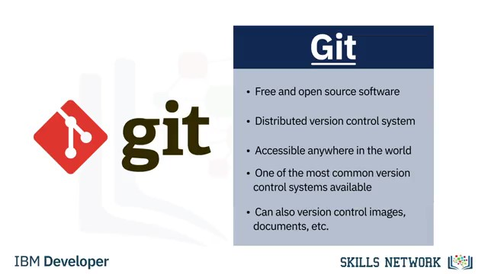

You can use Git without a web interface by using your command line interface, but GitHub is one of the most popular web-hosted services for Git repositories

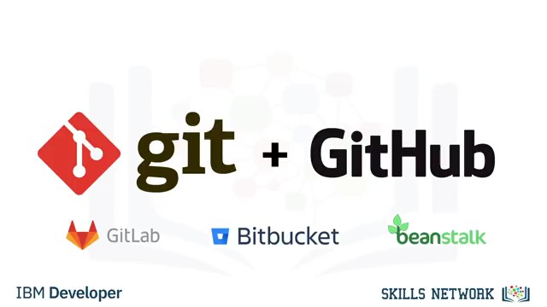

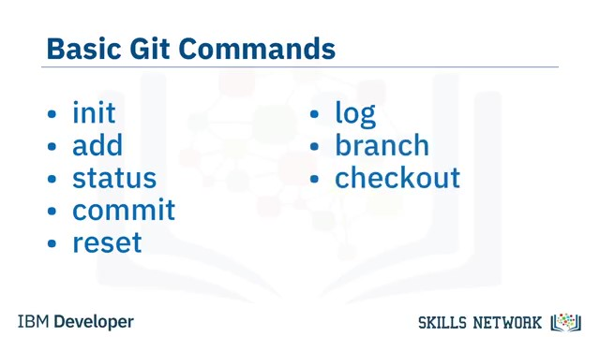

There are a few basic Git commands that you will always use.

When starting out with a new repository, you only need create it once: either locally,

and then push to GitHub, or by cloning an existing repository by using the command "git init".

"git add" moves changes from the working directory to the staging area.

"git status" allows you to see the state of your working directory and the staged snapshot

of your changes.

"git commit" takes your staged snapshot of changes and commits them to the project.

"git reset" undoes changes that you’ve made to the files in your working directory. "git log" enables you to browse previous changes to a project.

"git branch" lets you create an isolated environment within your repository to make changes.

"git checkout" lets you see and change existing branches.

"git merge" lets you put everything back together again.

